**Assignment OS**

A. Create a basic calculator with using case.

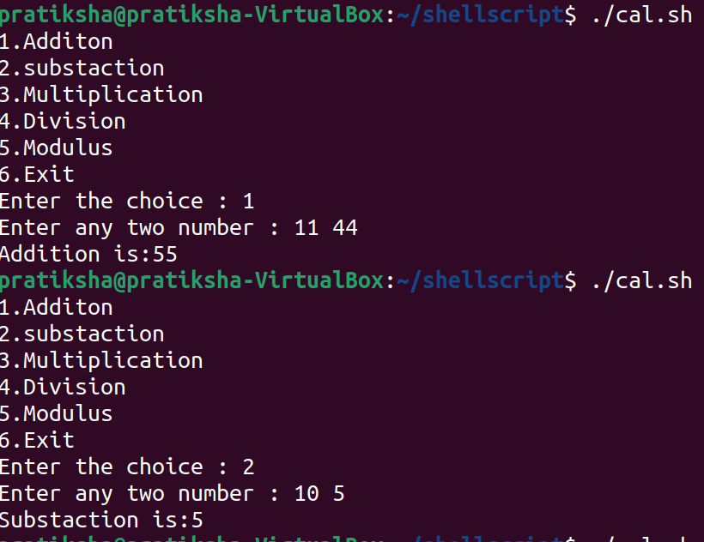

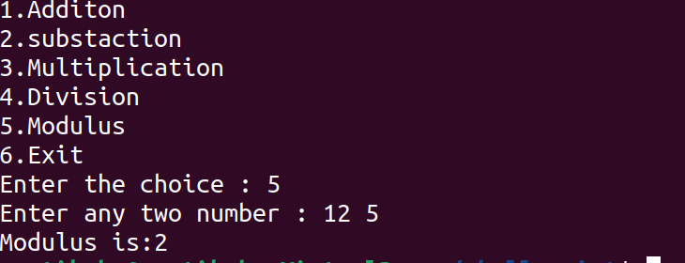

Output:

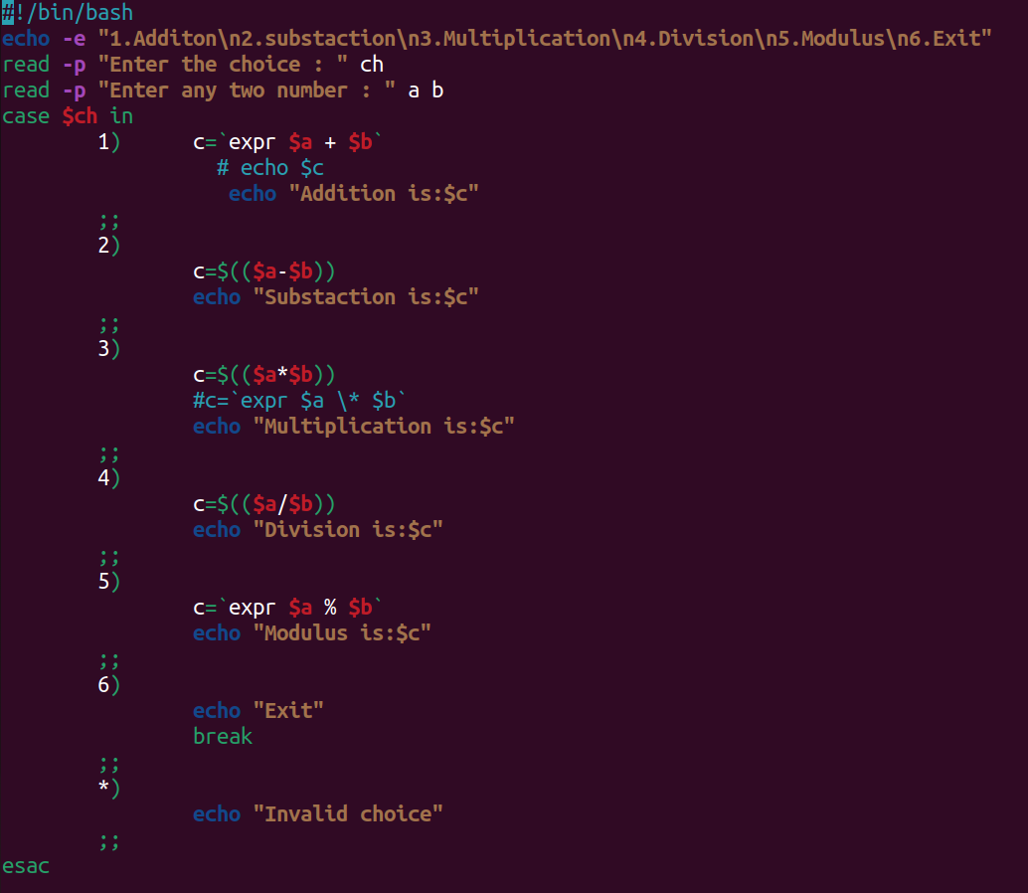

B. Find out the greatest number among three numbers entered by users using if condition

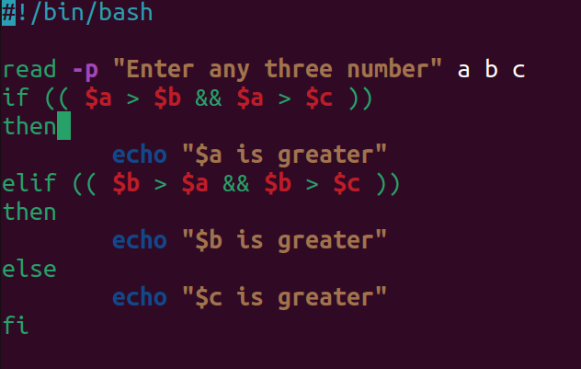

Output:

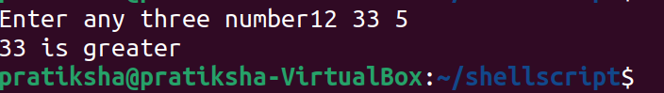

C. Write a program to take input of number from user and generate that number of .txt files.

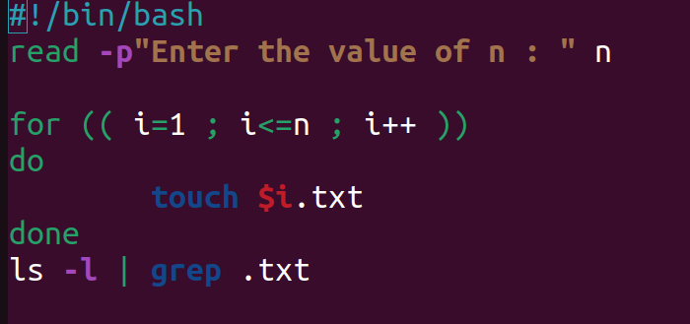

Output:

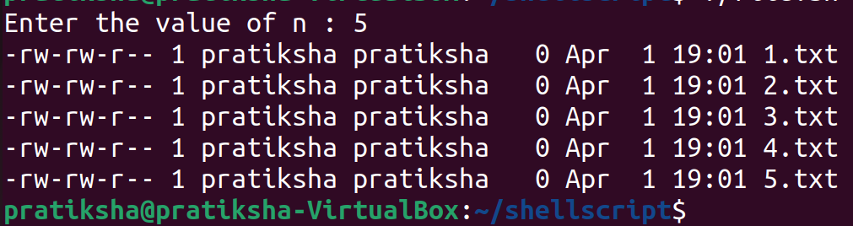

D. Write a program to check whether the number is even or odd?

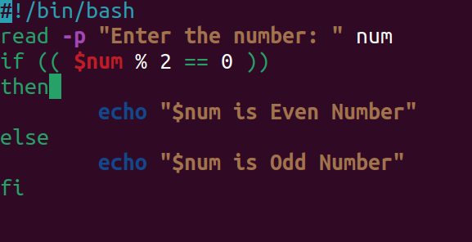

Output:

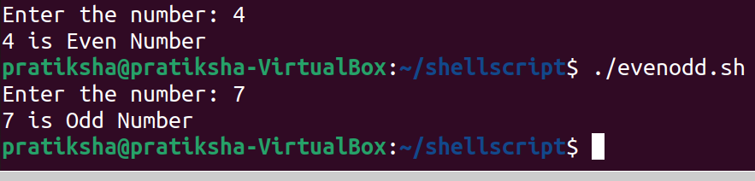

E. Follow the group file and compelete the tasks mentioned inside it.

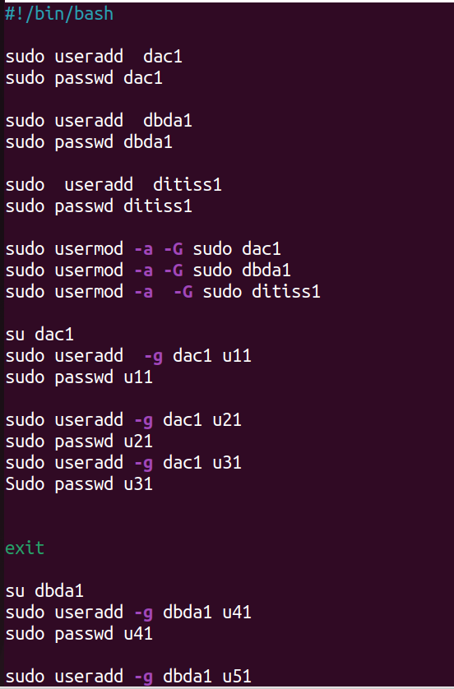

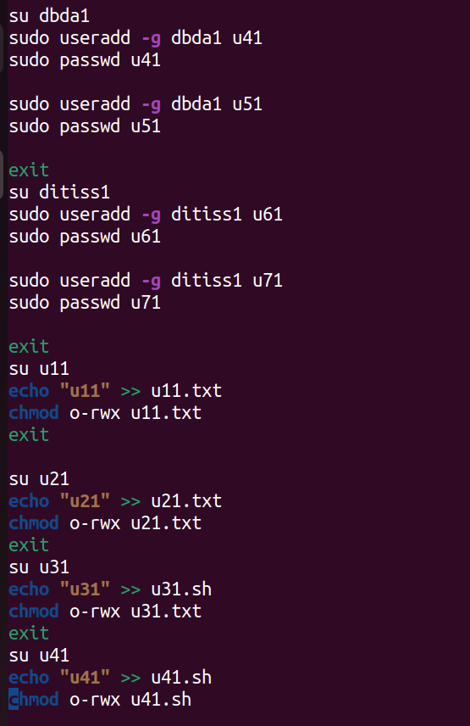

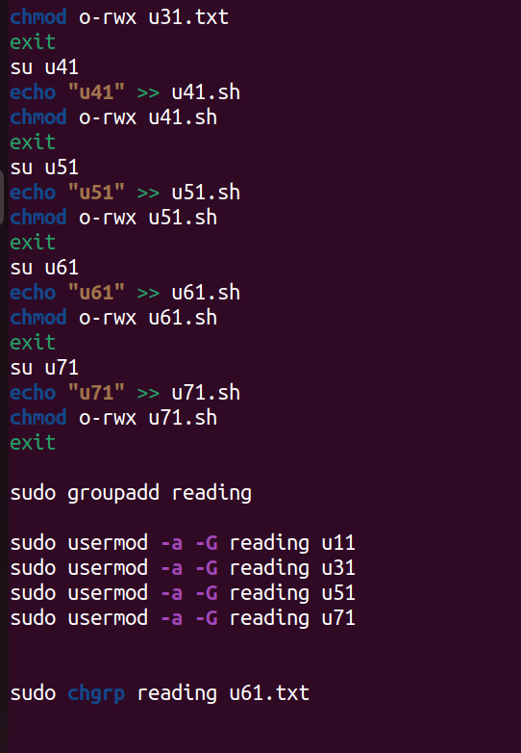

Loop Excercise (Use For/While/Until)

1. Write a Shell Script to display the first 10 natural numbers.

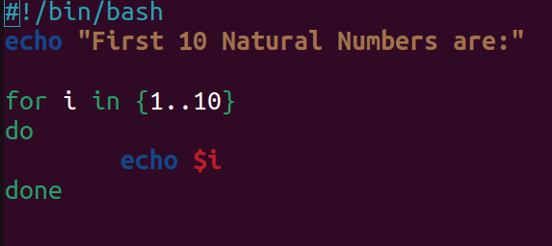

Output:

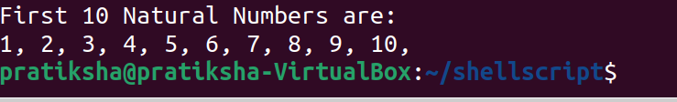

2. Write a Shell Script to compute the sum of the first 10 natural numbers.

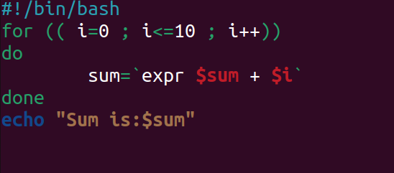

OutPut:

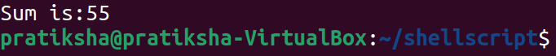

3. Write a Shell Script to display n terms of natural numbers and their sum.

Test Data : 7

Expected Output :

The first 7 natural number is :

1 2 3 4 5 6 7

The Sum of Natural Number upto 7 terms : 28

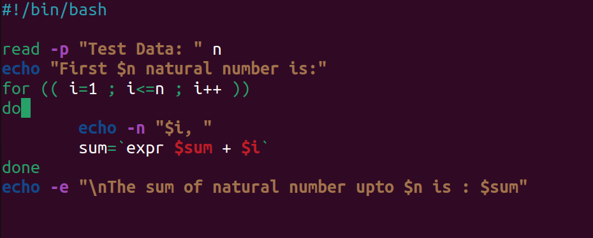

Output:

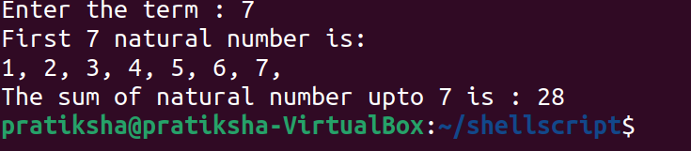

4. Write a Shell Script to read 10 numbers from the keyboard and find their sum and average.

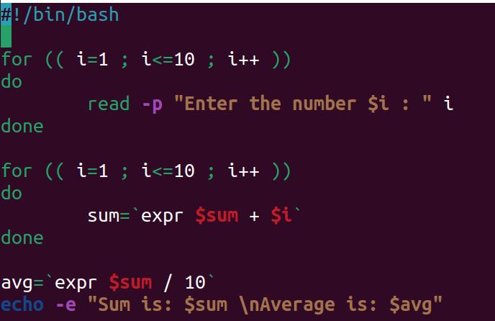

Output:

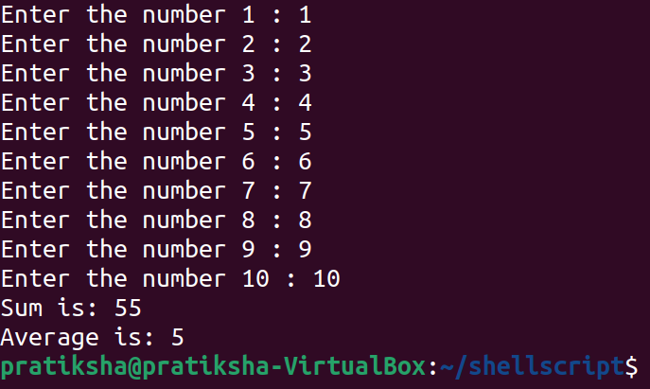

5. Write a Shell Script to display the cube of the number up to an integer.

Test Data :

Input number of terms : 5

Expected Output :

Number is : 1 and cube of the 1 is :1

Number is : 2 and cube of the 2 is :8

Number is : 3 and cube of the 3 is :27

Number is : 4 and cube of the 4 is :64

Number is : 5 and cube of the 5 is :125

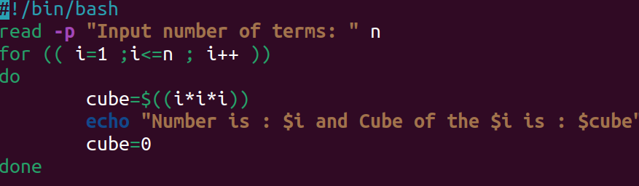

Output:

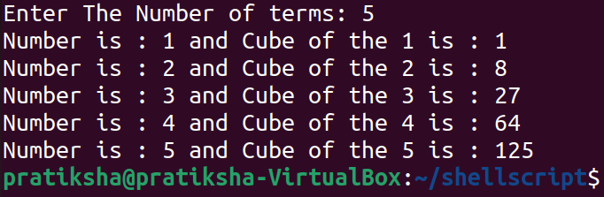

6. Write a Shell Script to display the multiplication table for a given integer.

Test Data :

Input the number (Table to be calculated) : 15

Expected Output :

15 X 1 = 15

...

...

15 X 10 = 150

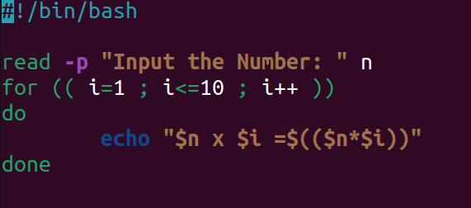

Output:

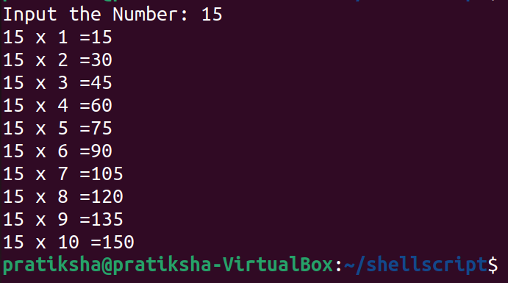

7. Write a Shell Script to display the multiplier table vertically from 1 to n.

Test Data :

Input upto the table number starting from 1 : 8

Expected Output :

Multiplication table from 1 to 8

1x1 = 1, 2x1 = 2, 3x1 = 3, 4x1 = 4, 5x1 = 5, 6x1 = 6, 7x1 = 7, 8x1 = 8

...

1x10 = 10, 2x10 = 20, 3x10 = 30, 4x10 = 40, 5x10 = 50, 6x10 = 60, 7x10 = 70, 8x10 = 80

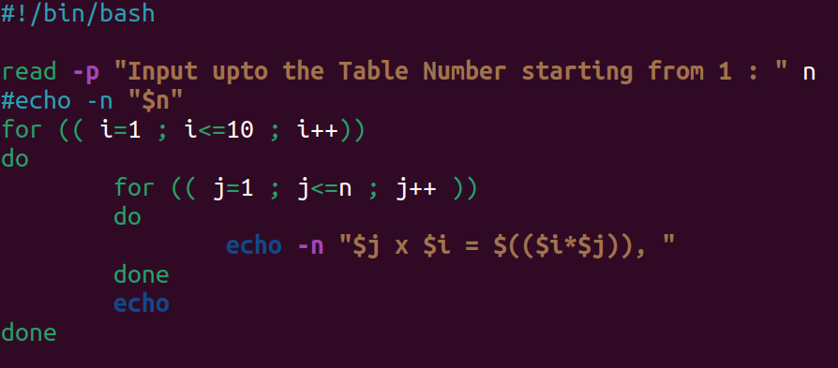

Output:

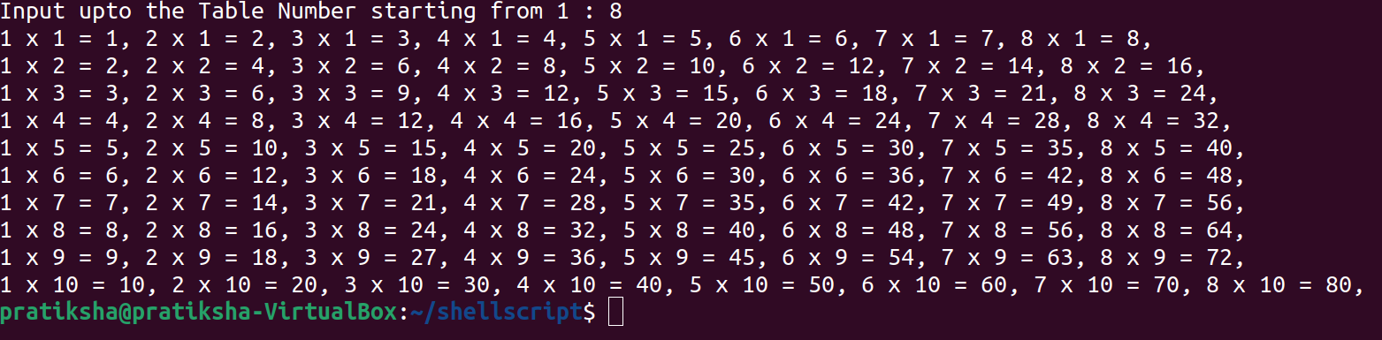

8. Write a Shell Script to display the n terms of odd natural numbers and their sum.

Test Data

Input number of terms : 10

Expected Output :

The odd numbers are :1 3 5 7 9 11 13 15 17 19

The Sum of odd Natural Number upto 10 terms : 100

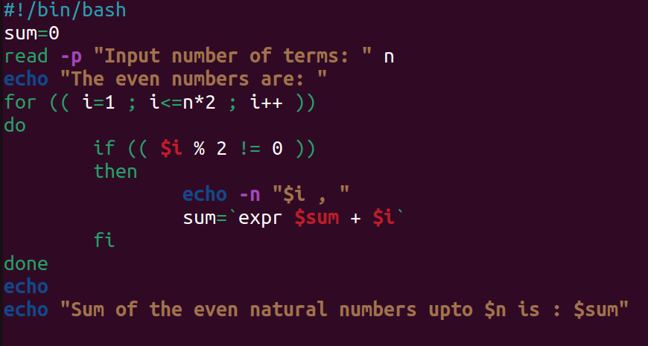

Output:

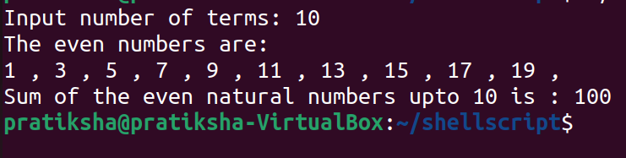

9. Write a Shell Script to display a pattern like a right angle triangle using an asterisk.

The pattern like :

*

**

***

****

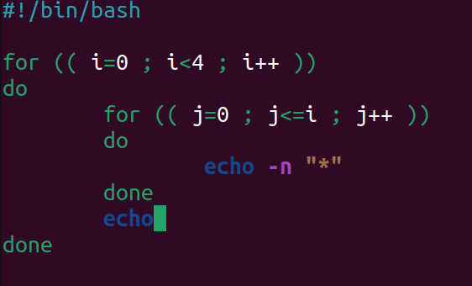

Output:

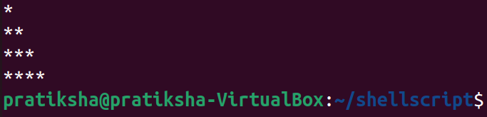

10. Write a Shell Script to display a pattern like a right angle triangle with a number.

The pattern like :

1

12

123

1234

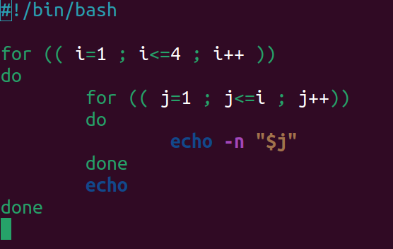

Output:

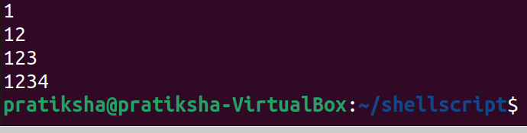

11. Write a Shell Script to make such a pattern like a right angle triangle with a number which will repeat a number in a row.

The pattern like :

1

22

333

4444

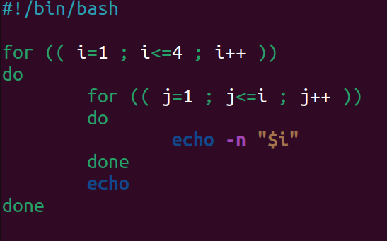

Output:

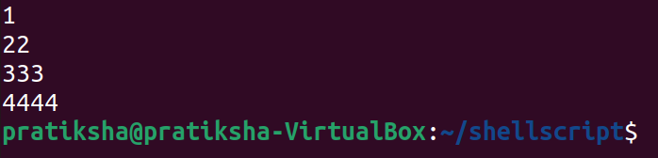

12. Write a Shell Script to make such a pattern like a right angle triangle with the number increased by 1. The pattern like :

1

2 3

4 5 6

7 8 9 10

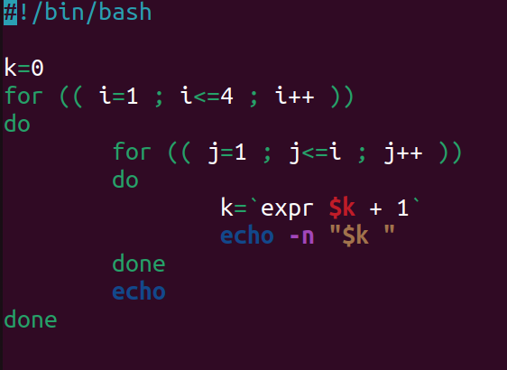

Output:

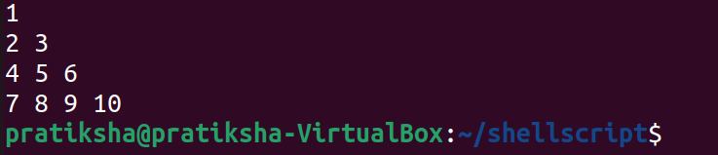

13. Write a Shell Script to make a pyramid pattern with numbers increased by 1.

1

2 3

4 5 6

7 8 9 10

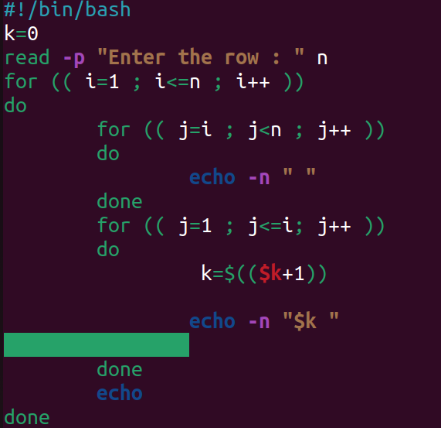

Output:

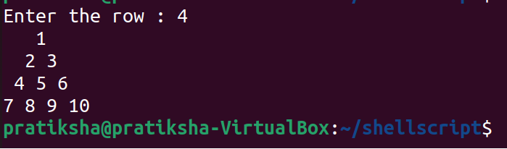

14. Write a Shell Script to make such a pattern as a pyramid with an asterisk.

*

* *

* * *

* * * *

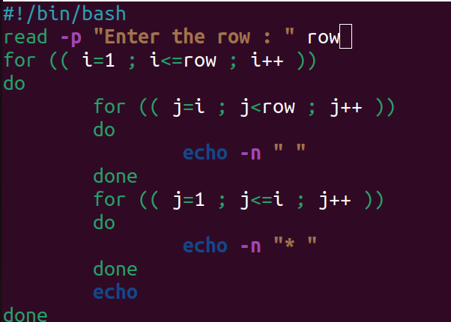

Output:

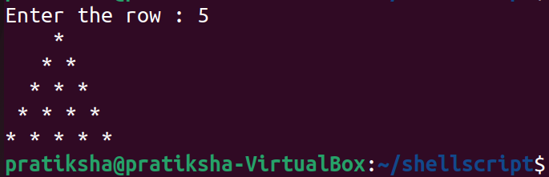

15. Write a Shell Script to calculate the factorial of a given number.

Test Data :

Input the number : 5

Expected Output :

The Factorial of 5 is: 120

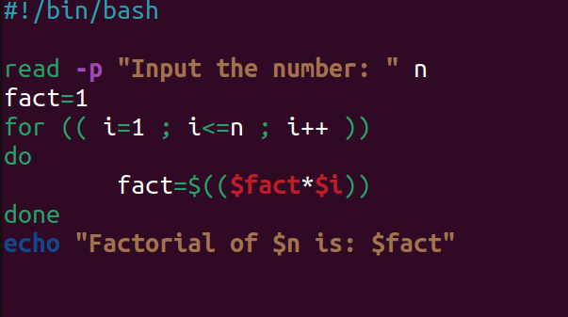

Output:

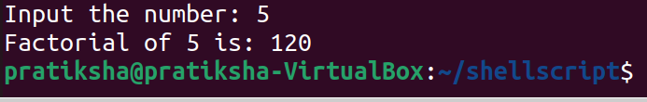

16. Write a Shell Script to display the sum of n terms of even natural numbers.

Test Data :

Input number of terms : 5

Expected Output :

The even numbers are :2 4 6 8 10

The Sum of even Natural Number upto 5 terms : 30

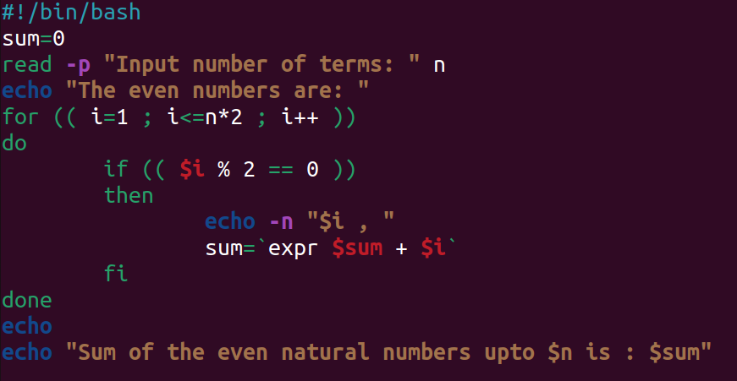

Output:

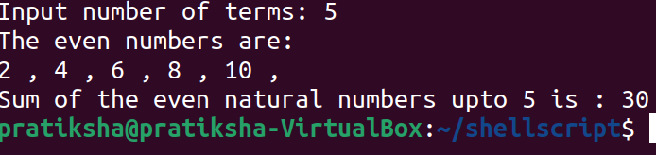

17. Write a Shell Script to make such a pattern like a pyramid with a number which will repeat the number in the same row.

1

2 2

3 3 3

4 4 4 4

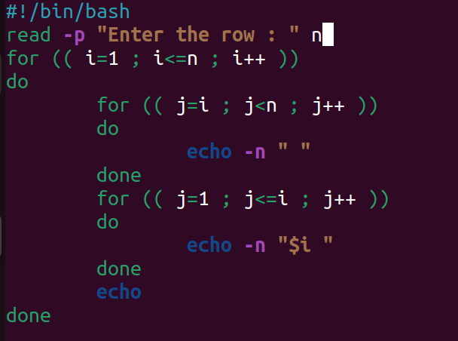

Output:

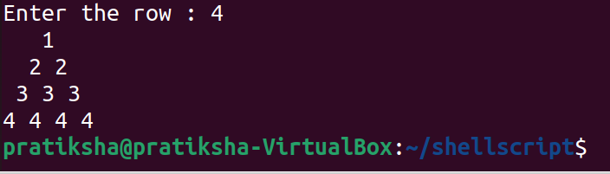

18. Write a Shell Script to find the sum of the series [ 1-X^2/2!+X^4/4!- .........].

Test Data :

Input the Value of x :2

Input the number of terms : 5

Expected Output :

the sum = -0.415873

Number of terms = 5

value of x = 2.000000

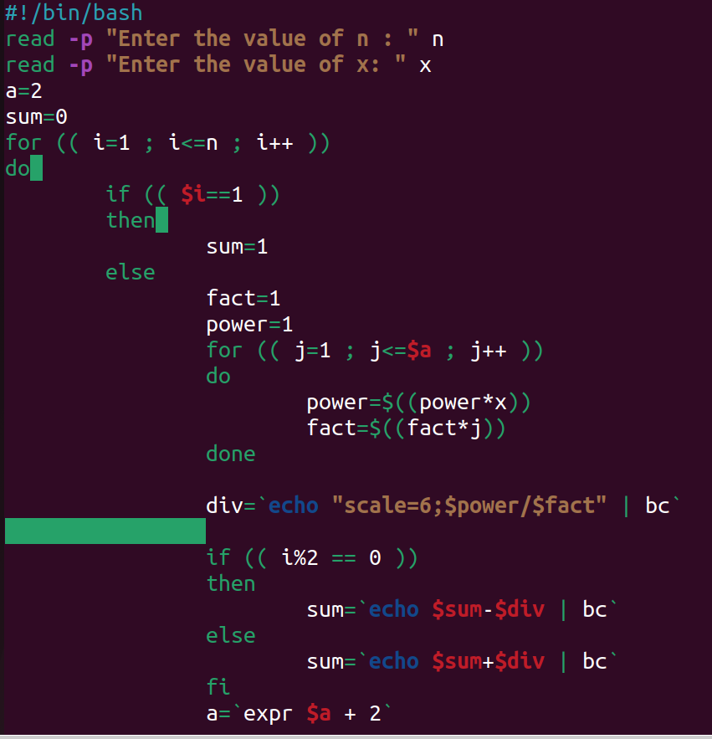

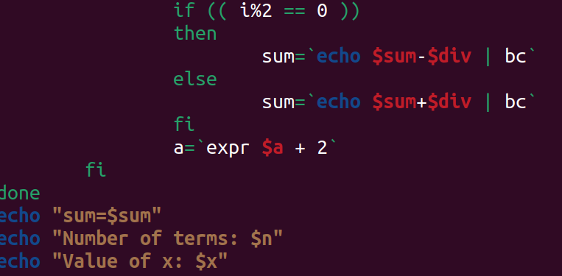

Output:

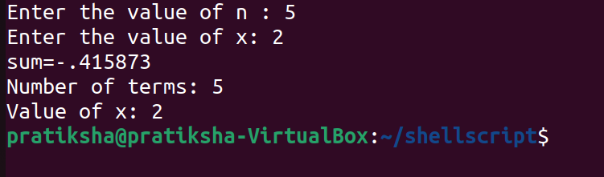

19. Write a Shell Script to display the n terms of a harmonic series and their sum.

1 + 1/2 + 1/3 + 1/4 + 1/5 ... 1/n terms

Test Data :

Input the number of terms : 5

Expected Output :

1/1 + 1/2 + 1/3 + 1/4 + 1/5 +

Sum of Series upto 5 terms : 2.283334

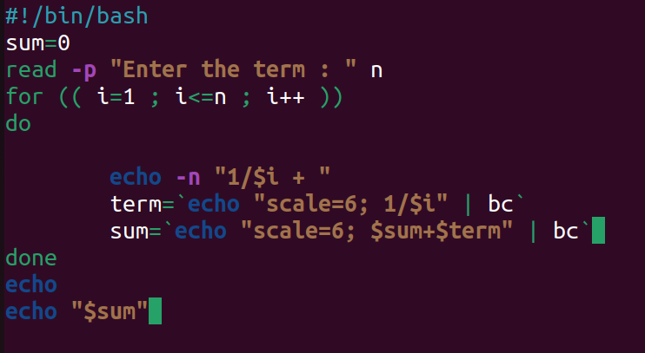

Output:

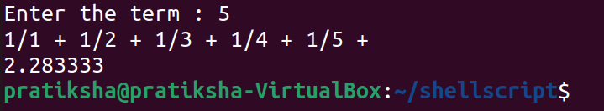

20. Write a Shell Script to display the pattern as a pyramid using asterisks, with each row containing an odd number of asterisks.

*

***

*****

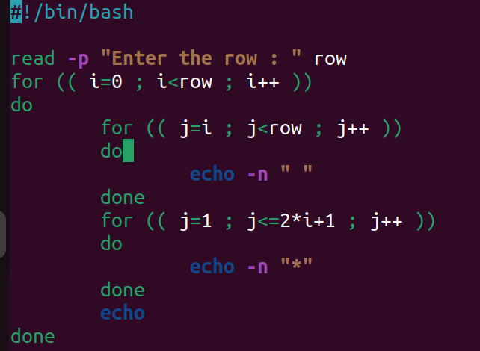

Output:

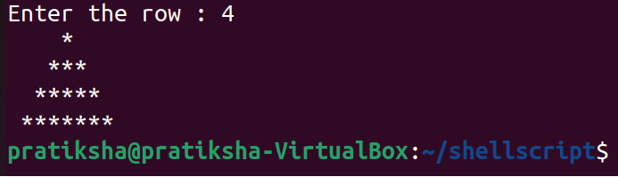

21. Write a Shell Script to display the sum of the series [ 9 + 99 + 999 + 9999 ...].

Test Data :

Input the number or terms :5

Expected Output :

9 99 999 9999 99999

The sum of the saries = 111105

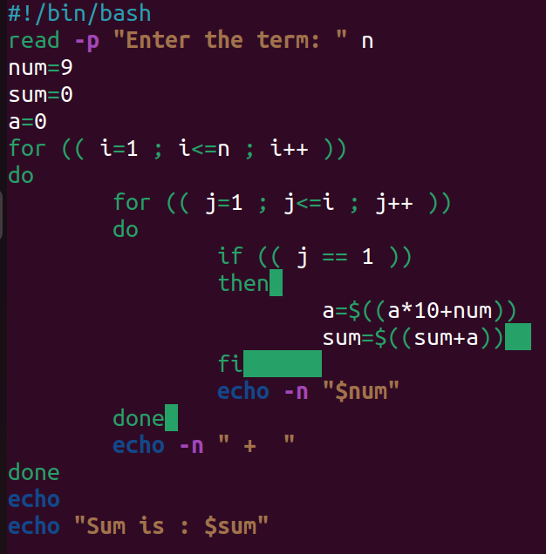

Output:

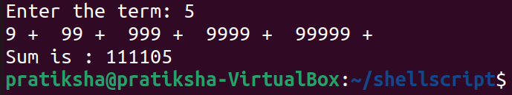

22. Write a Shell Script to print Floyd's Triangle.

1

01

101

0101

10101

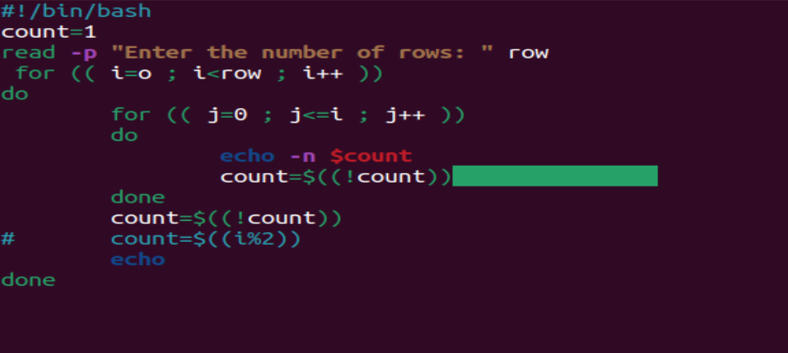

Output:

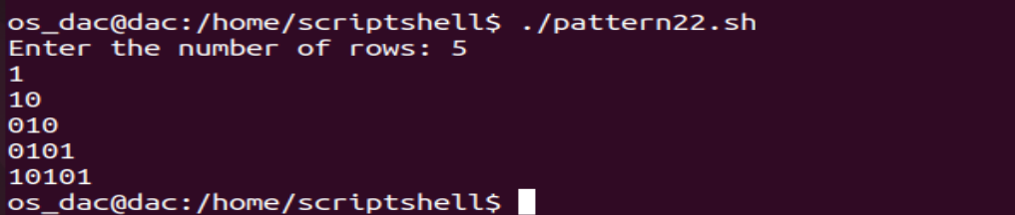

23. Write a Shell Script to find the sum of the series [x - x^3 + x^5 + ......].

Test Data :

Input the value of x :3

Input number of terms : 5

Expected Output :

The sum is : 16.375000

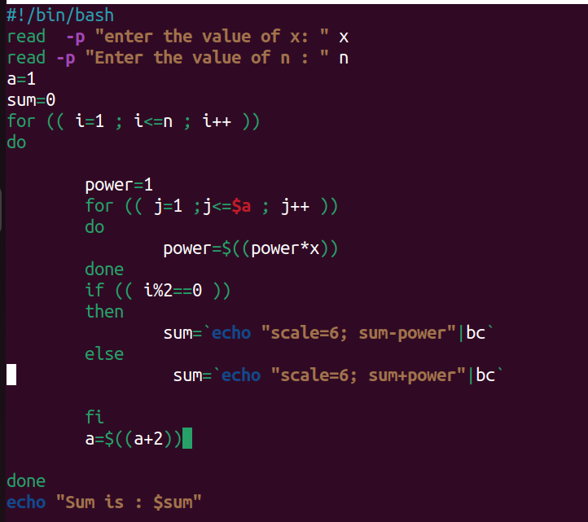

Output:

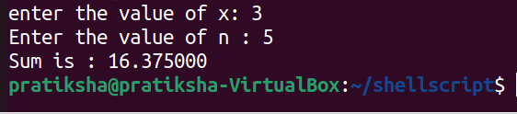

24. Write a Shell Script to find the sum of the series [ x - x^3 + x^5 + ......].

Test Data :

Input the value of x :2

Input number of terms : 5

Expected Output :

The values of the series:

22

-8

32

-128

512

The sum = 410

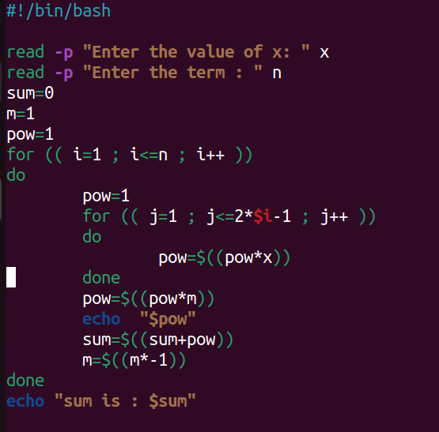

Output:

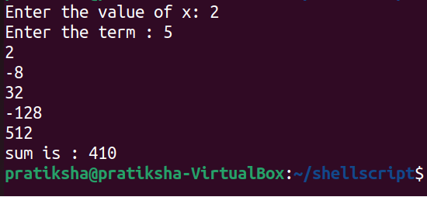

25. Write a Shell Script that displays the n terms of square natural numbers and their sum.

1 4 9 16 ... n Terms

Test Data :

Input the number of terms : 5

Expected Output :

The square natural upto 5 terms are :1 4 9 16 25

The Sum of Square Natural Number upto 5 terms = 55

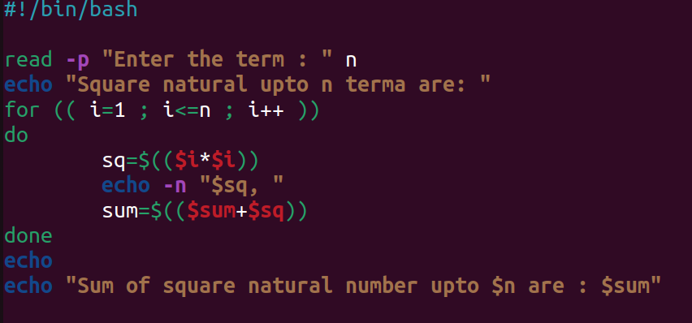

Output:

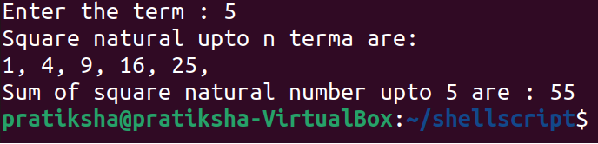

26. Write a Shell Script to find the sum of the series 1 +11 + 111 + 1111 + .. n terms.

Test Data :

Input the number of terms : 5

Expected Output :

1 + 11 + 111 + 1111 + 11111

The Sum is : 12345

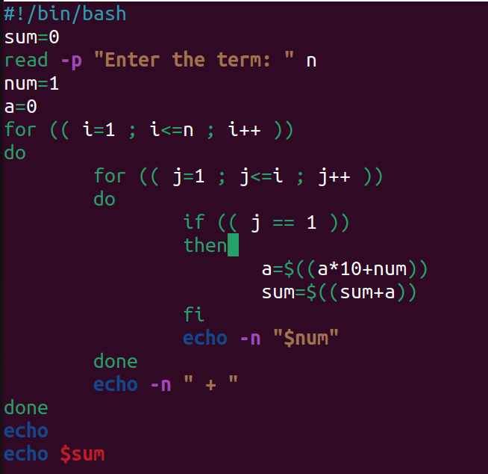

Output:

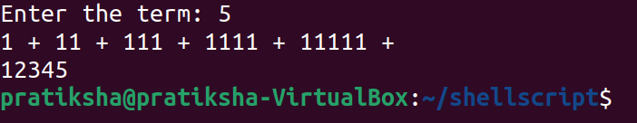

27. Write a Shell Script to check whether a given number is a 'Perfect' number or not.

Test Data :

Input the number : 56

Expected Output :

The positive divisor : 1 2 4 7 8 14 28

The sum of the divisor is : 64

So, the number is not perfect.

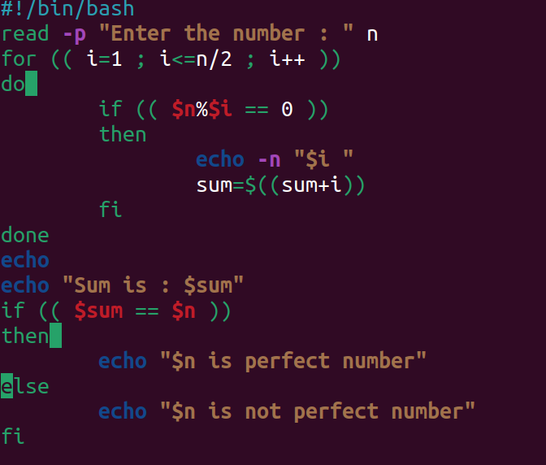

Output:

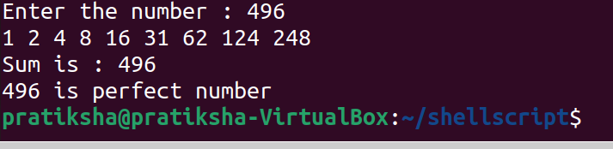

28. Write a Shell Script to find the 'Perfect' numbers within a given number of ranges.

Test Data :

Input the starting range or number : 1

Input the ending range of number : 50

Expected Output :

The Perfect numbers within the given range : 6 28

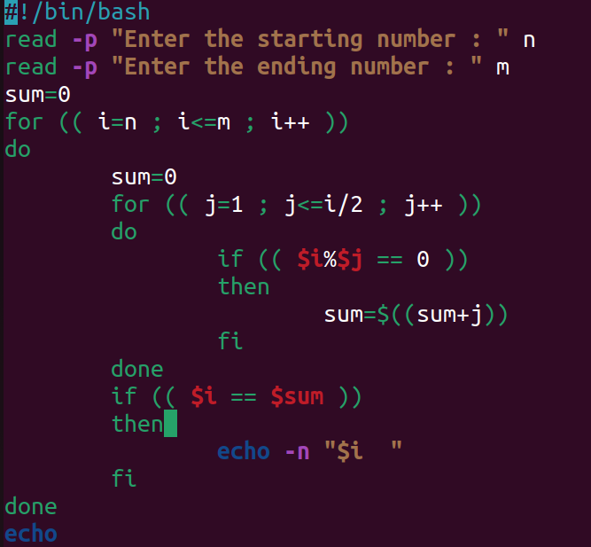

Output:

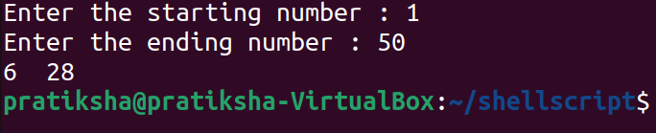

29. Write a Shell Script to check whether a given number is an Armstrong number or not.

Test Data :

Input a number: 153

Expected Output :

153 is an Armstrong number.

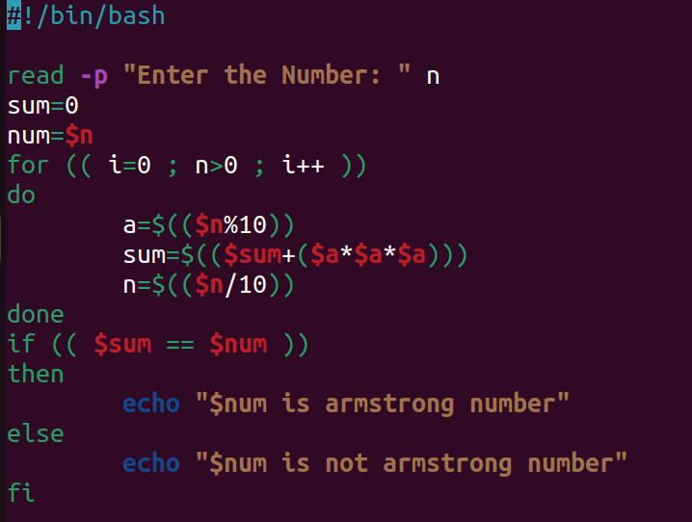

Output:

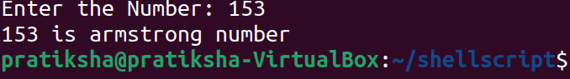

30. Write a Shell Script to find the Armstrong number for a given range of number.

Test Data :

Input starting number of range: 1

Input ending number of range : 1000

Expected Output :

Armstrong numbers in given range are: 1 153 370 371 407

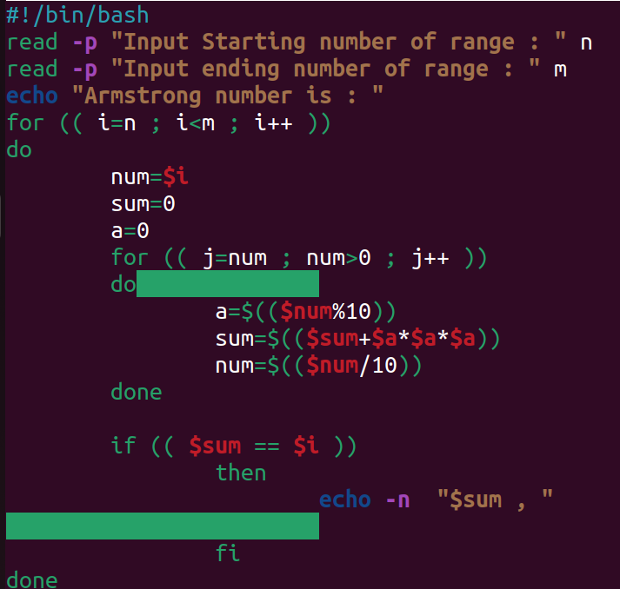

Output:

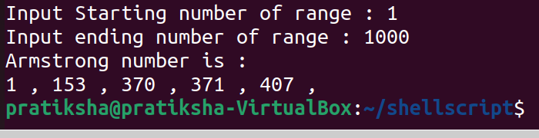

31. Write a Shell Script to display a pattern like a diamond.

*

***

*****

*******

*********

*******

*****

***

*

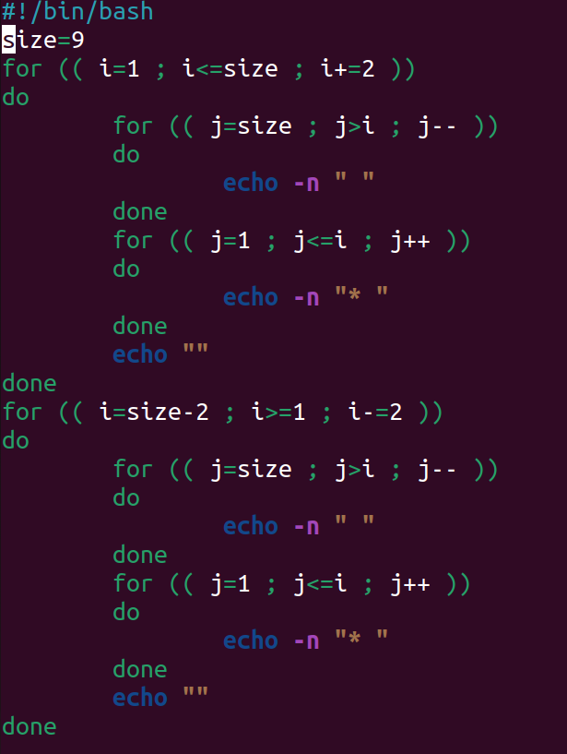

Output:

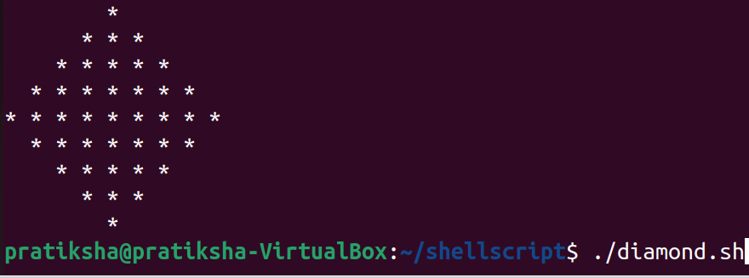

32. Write a Shell Script to determine whether a given number is prime or not.

Test Data :

Input a number: 13

Expected Output :

13 is a prime number.

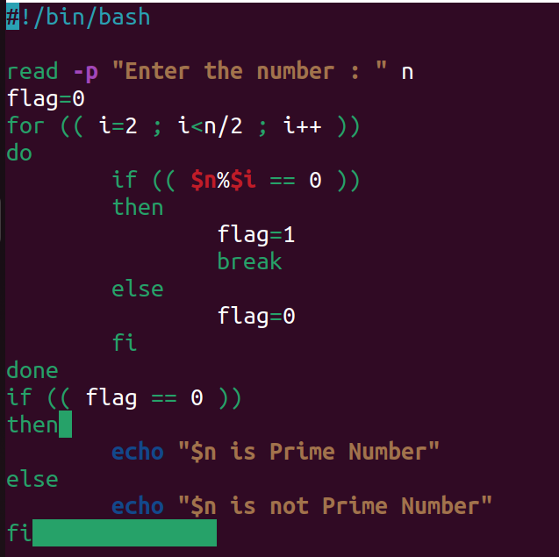

Output:

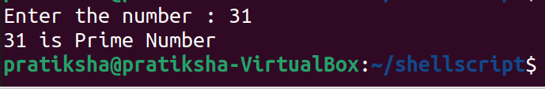

33. Write a Shell Script to display Pascal's triangle.

Test Data :

Input number of rows: 5

Expected Output :

1

1 1

1 2 1

1 3 3 1

1 4 6 4 1

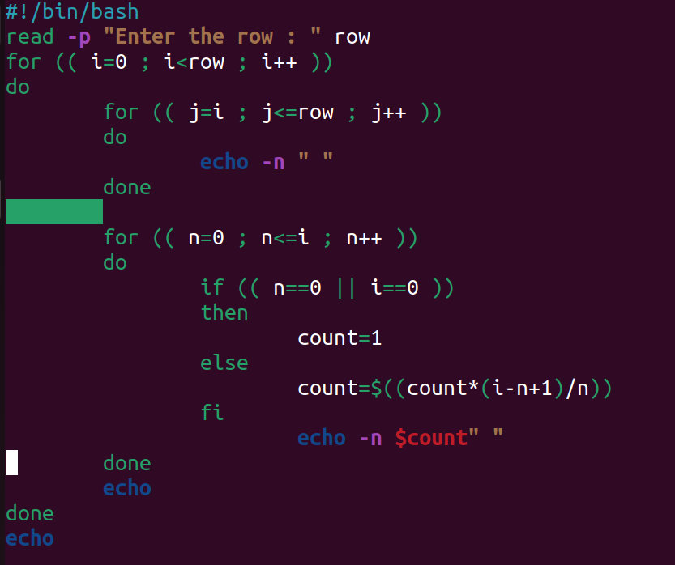

Output:

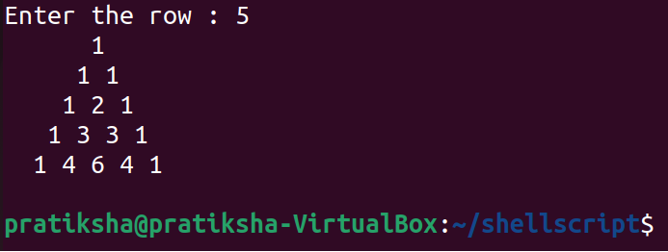

34. Write a Shell Script to find the prime numbers within a range of numbers.

Test Data :

Input starting number of range: 1

Input ending number of range : 50

Expected Output :

The prime number between 1 and 50 are :

2 3 5 7 11 13 17 19 23 29 31 37 41 43 47

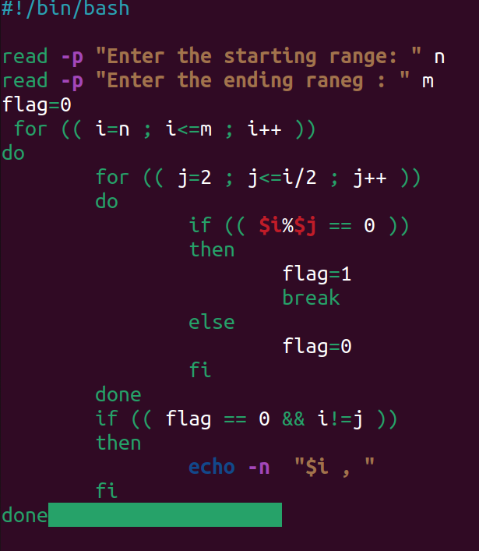

Output:

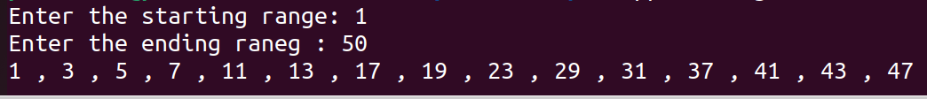

35. Write a Shell Script to display the first n terms of the Fibonacci series.

Fibonacci series 0 1 2 3 5 8 13 .....

Test Data :

Input number of terms to display : 10

Expected Output :

Here is the Fibonacci series upto to 10 terms :

0 1 1 2 3 5 8 13 21 34

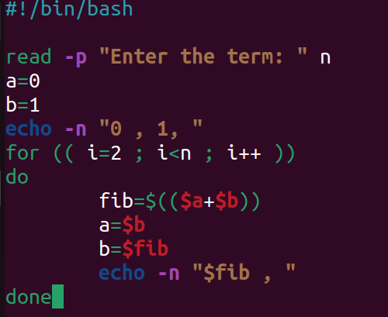

Output:

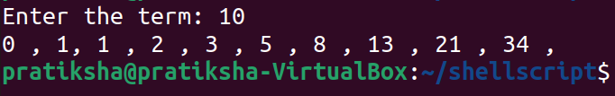

36. Write a Shell Script to display a such a pattern for n rows using a number that starts with 1 and each row will have a 1 as the first and last number.

1

121

12321

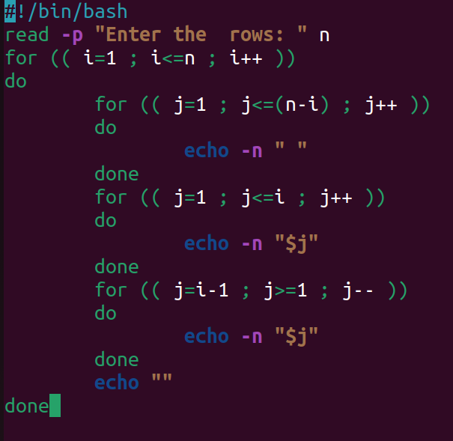

Output:

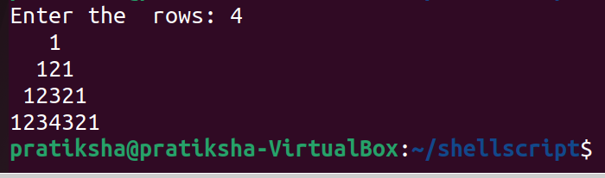

37. Write a Shell Script to display the number in reverse order.

Test Data :

Input a number: 12345

Expected Output :

The number in reverse order is : 54321

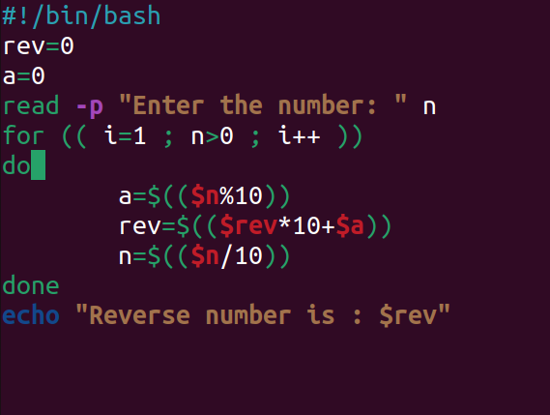\

Output:

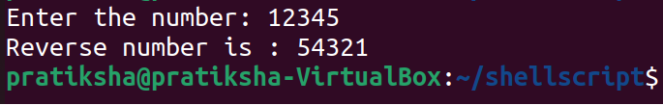

38. Write a Shell Script to check whether a number is a palindrome or not.

Test Data :

Input a number: 121

Expected Output :

121 is a palindrome number.

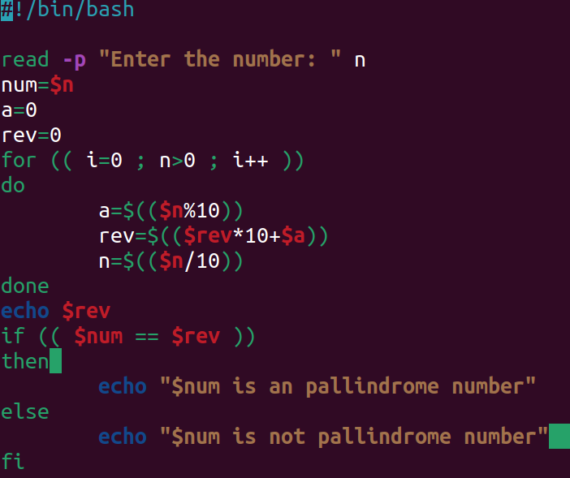

Output:

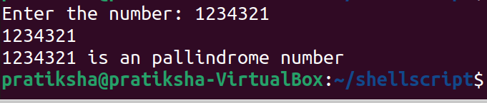

39. Write a Shell Script to find the number and sum of all integers between 100 and 200 which are divisible by 9.

Expected Output :

Numbers between 100 and 200, divisible by 9 :

108 117 126 135 144 153 162 171 180 189 198

The sum : 1683

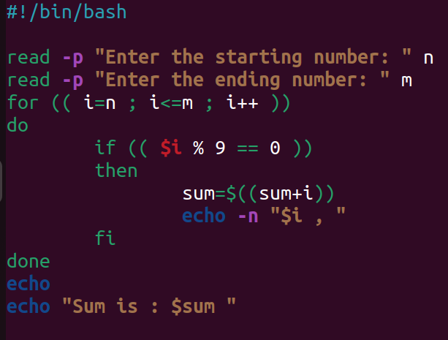

Output:

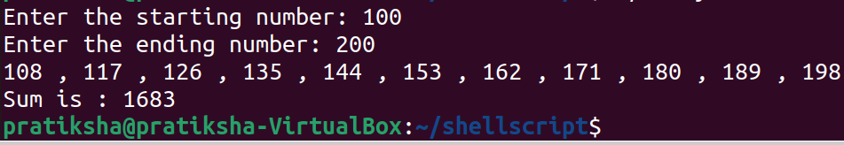

40. Write a Shell Script to display the pyramid pattern using the alphabet.

A

A B A

A B C B A

A B C D C B A

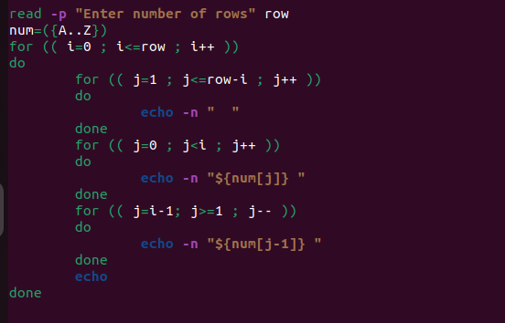

Output:

